

FOR RELEASE MEDIA CONTACT May 2, 2023 Jehan Williams, 770-498-5608 [jgwilliams@stonemountainpark.com](mailto:jgwilliams@stonemountainpark.com)

**Stone Mountain Park Hosts New Latino Family Festival and Light Show**

*Featuring Live International Talent and Drone and Light Show*

**Stone Mountain, Ga. –**The LatinoFamily Festival, an exciting new event celebrating Latino culture and heritage, is set to take place the first three weekends in May at Stone Mountain Park, Georgia’s No. 1 most visited attraction. The festival promises to be a vibrant and lively celebration of Latino music, dance, and culture, featuring a wide range of live international talent, including dancers, a marching band, storytellers, and a drone and light show.

The festival will feature live music and dance performances. Guests will have the opportunity to see traditional dances and entertainment from different regions of Latin America including Aztec dancers, Colombian ballet, Mexican ballet, Flamenco dancers, Mariachi band, Pleneros, Mexican band, Charro, stilt walkers, and Panamanian marching band. The festival will also include interactive storytelling sessions where guests can learn the significance of Latino traditions and folklore.

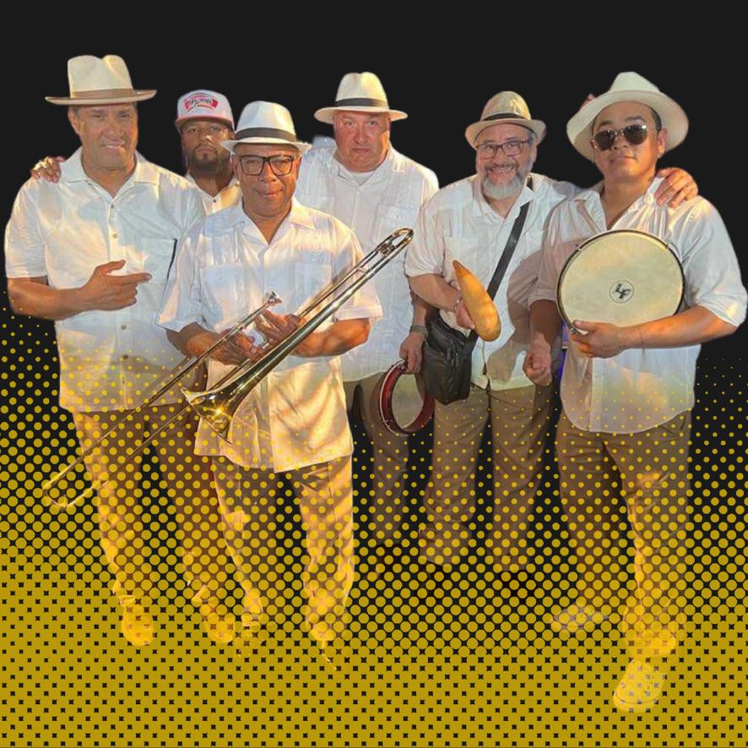

Image: Pleneros will be performing during the Latino Family Festival at Stone Mountain Park.

One of the highlights of the festival will be the drone and light show. End each evening with a festive drone show featuring more than 250 color-changing drones creating amazing aerial formations all synced to music. Then watch the specially programmed massive Latino Festival Light Show projecting images on the mountain along with immersive lighting and special effects, followed by a fireworks finale.

"We hope that the Latino Family Festival will become an annual tradition at Stone Mountain Park, bringing together people of all backgrounds to celebrate the beauty and richness of Latino culture," said Stan Morrell, Senior Vice President of Entertainment and Special Events. "We invite everyone to join us for this amazing event and experience the energy, passion, and joy of Latino music, dance, food, and culture."

The Latino Family Festival and Light Show will take place Saturdays and Sundays May 6 – 21. Additional festival information and tickets are available [here](https://stonemountainpark.com/activity/events/latino-family-festival/).

**Stone Mountain Park**Stone Mountain Park is 3200 acres of natural wonderland located 16 miles east of downtown Atlanta. To visit, take I-285 to Exit 39B, Hwy. 78 East. Stone Mountain Park is at Exit No. 8 on Hwy. 78. For ticketing and attractions details or hours of operation call 800-401-2407 or visit [www.stonemountainpark.com](http://www.stonemountainpark.com), or follow on [Facebook](https://facebook.com/stonemountainpark/) and [Instagram](https://instagram.com/stonemountainpark/) for updates.

###