Stone Mountain Park Hosts Lunar New Year Festival
featuring spectacular Drone and Light Show

STONE MOUNTAIN, Ga. – Stone Mountain Park’s second annual Lunar New Year Festival will celebrate the Year of the Dragon. This Asian-inspired festival pays tribute to the culture and New Year traditions of Korean, Chinese, Vietnamese, and other countries that follow the lunar calendar. It features a special Lunar New Year Drone and Light Show, a NEW lighted parade, cultural craft activities, live entertainment, and other cultural elements. The festival will occur February 10 – 11, 17 – 19, and 24 – 25.

Held in the Crossroads area and on the Memorial Lawn, visitors will experience traditional dance, cultural music, educational craft activations, dragon and lion dance teams, signature foods, beautiful décor, and much more.

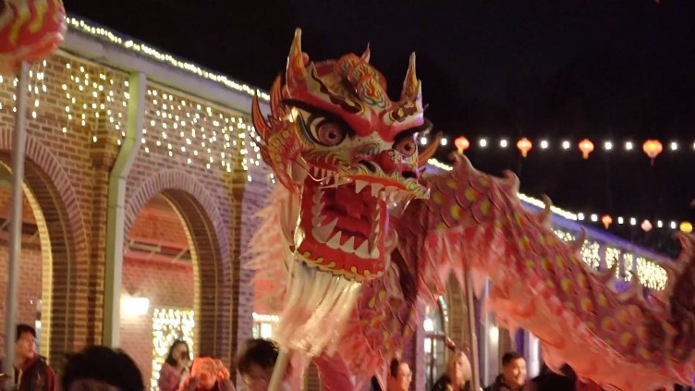

Photo: Dragon dance team at Stone Mountain Park

The event showcases cultural and educational activities for families to experience together. Learn calligraphy, yo-yo demonstrations, knot tying, and more from certified instructors from the Chinese Cultural School of Atlanta. Pose for pictures with ambassadors dressed in cultural dress and stationary backdrops throughout the event. Visit the Lighted Reflection Walk-Way to offer well wishes and prayers for a prosperous new year.

End each evening with a festive Drone Show featuring over 250 color-changing drones creating amazing aerial formations synced to music, then watch the massive Lunar New Year Light Show projecting images on the mountain along with immersive lights and special effects, followed by a fireworks finale.

Page 2 – Lunar New Year Festival at Stone Mountain Park

For tickets and information, please visit www.stonemountainpark.com

Listed in Frommer’s 500 Places to Visit with Your Kids Before They Grow Up and cited by the Atlanta Journal-Constitution as one of “35 Natural Wonders in Georgia You Must See Before You Die,” Stone Mountain Park is located 15 miles east of downtown Atlanta. For more information, visit www.stonemountainpark.com, or follow on Facebook and Instagram for updates.

# # #
Editors

B-Roll: Link

Video: Link

